Analysis of Maritime Safety Reports Received 2023-2024

Introduction
CHIRP improves safety at sea through the provision of a confidential and independent incident and near miss reporting programme. When appropriate, and with the reporters’ permission, these issues are passed on to company DPAs, Flag States, Classification Societies or Unions so that they can be addressed. Reporters’ identities are never passed on and always protected. We can also connect reporters to appropriate welfare organisations who are best placed to directly assist the reporter.
The annual reporting cycle begins 01 April and completes 31 March the following year. This report covers the period 2023-2024.
Analysis of reports indicates that pilot ladders (Pilot Transfer Arrangements, or PTAs) and intentional deviations from safety procedures remain the main causes of near misses, while fires and enclosed space incident are the main incident causes. Tragically, over 50% of reports submitted to CHIRP resulted in one or more fatalities, almost all of which were the result of entry into enclosed spaces which had not been sufficiently ventilated beforehand. The next leading cause of reported deaths was people unintentionally falling into the water (MOB) who were not wearing lifejackets.

Incident vs near miss reports
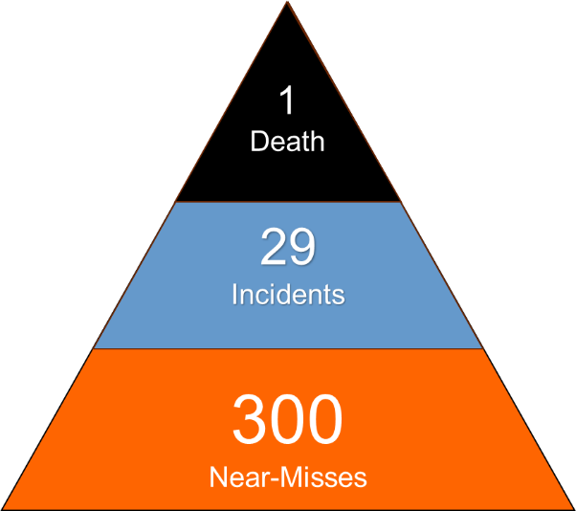
CHIRP uses different frameworks to analyse the significance of data we receive. One such widely used framework is the Heinrich ratio that describes the number of near misses to actual serious incidents: for every incident resulting in major harm, there may be expected to be 30 resulting in minor harm and 300 ‘near-misses’. CHIRP actively promotes near-miss reporting.

Figure 1: Heinrich Model

In 2023-2024, 38% of the maritime reports received by CHIRP were for near misses, and 62% were incidents. Under-reporting of near misses is not an issue unique to the maritime industry, which often go unreported for several powerful reasons including fear of being judged by their peers and managers, or simply not recognising that a near miss had occurred. CHIRP encourages organisations and managers to actively champion and encourage near miss reporting, because they are powerful tools that reduce the frequency of serious incidents.

Analysis of reports

Near Misses

Figure 2: The most frequently cited causes of near miss reports received by CHIRP.

The most frequently-cited causes of Near Miss reports (figure 2) were unsafe or non-compliant Pilot Ladders (33%), deliberate deviation from safe standard operating procedures (17%) and fire danger (15%) which was matched by a collection of reasons caused either by people or equipment operating unsafely at height. The remaining 20% were caused by various other causes.

Incidents
Fires (12%), entry into enclosed spaces (11%), persons falling overboard (9%) and hand injuries caused by crushing or rotating machinery (7%) were cited as the cause of over 40% of all reported incidents (figure 3). This year, there has been a marked increase in the number of ABDHV incidents reported to CHIRP. When bench-marked against statistics published by several maritime welfare charities, this is almost certainly under-reported, but nevertheless highlights the intrinsic link between welfare and safety.

Figure 3: The most frequently cited causes of incident reports received by CHIRP.

Incident outcomes
The human cost of incidents is stark: over half of the incidents reported to CHIRP resulted in personal injury (29%) or death (24%). While these findings likely overstate the overall severity of incident outcomes, the lack of a global system to accurately collate the number of fatalities at sea stymies efforts at precision. Even acknowledging their likely inaccuracy, they nevertheless highlight the moral imperative to learn from incidents, and the need to share this learning across organisational boundaries through neutral agents such as CHIRP.
34% of incidents resulted in costly damage to equipment. Environmental damage was the result of a further 5% of reported incidents. In only 8% of reported incidents was there a minimal consequence.

Analysis of Human Factors
CHIRP analyses maritime reports using the SHIELD human factors taxonomy which has 144 factors across 4 hierarchical levels: Acts, Preconditions, Operational Leadership, and Organisation. These are then mapped to the more widely employed Deadly Dozen prior to publication. On average, each report contained 7 SHIELD factors, although up to 17 were identified in the most complex cases. Table 1. The most frequently identified SHIELD factors, and their mapping to the Deadly Dozen, are shown in table 1.

SHIELD Factor | SHIELD code | Deadly Dozen equivalent
Acts
Incorrect decision or plan | AD1 | Local Practices
No transmission of information | AC2 | Communication
Workaround in normal conditions | AI1 | Deviation
No/wrong/late visual detection | AP1 | Situational Awareness
No/wrong/late detection by other means | AP4 | Situational Awareness
Preconditions
Inattention | PAW4 | Distraction
Risk underestimation | PPF7 | Complacency
No cross-check or speaking up | PTG2 | Alerting
Operational Leadership
Inadequate risk assessment | LO1 | Complacency
Inadequate leadership/supervision | LT1 | Teamwork
Organisation
Safety culture | OC1 | Culture
Insufficient personnel | OR1 | Pressure
Design | OR5 | - No direct mapping-
Safety management (proactive) | OS2 | Culture
Safety management (reactive) | OS3 | Culture
Table 1: The top Human Factors identified from reports received by CHIRP.

This list of factors remains largely unchanged from those identified in 2023 and 2022. This is perhaps understandable because behavioural change takes time, however companies and organisations are strongly encouraged to focus on addressing these causal factors.
The notable addition to this list is design: CHIRP increasingly receives reports where equipment design either contains inherent safety weaknesses, or equipment is installed in such a way that it cannot be operated or maintained safely. Recurrent examples include inadequate or missing attachment points for safety harnesses; stanchions or other deck fittings which create trip hazards around mooring bollards; missing safety interlocks on moving machinery; or designs which make it difficult or impossible to inspect and maintain safety-critical equipment eg lifting eye-bolts.
Overall, these factors suggest a generic trail for safety incidents “from the Board Room to the Bridge”:
- At the organisational level, commercial pressures do not incentivise companies to resource its operations over and above regulatory mandated minima. Should formal risk assessment fail to suggest otherwise, this can result in too few crew (particularly Bridge lookouts and OOW) or time schedules that are too lean. Either can lead to inadequate supervision or assurance of tasks, inadequate risk assessment and planning of high-risk activities, or unsafe short-cuts taken.
- Concurrent activities and competing demands lead to distracted and inattentive crews who are multi-tasking. Risk underestimation and a lack of cross-checking by a supervisor or a colleague leads to the creation of workarounds in normal conditions. Optimism bias (“It didn’t/won’t happen to me”) discourages adequate task planning, particularly in a time-constrained environment. Availability bias means that weight is given to the probability of an event happening based on previous experience, which can affect perception of the risk. Inadequate reporting exacerbates this problem.
- Dangerous situations that arise are not detected or detected too late to be averted, resulting in safety incidents.
Much of this stems from there being insufficient personnel, or inadequate time to properly plan and control tasks in a safe manner. It suggests that organisations who exceed regulatory minima will be safer as a result.
Although the consequences of incidents were invariably experienced on board, several of the factors which contributed to incidents originated ashore, ie at the senior management level, as evidenced by the list of factors in table 1 under ‘Organisation’.

Evaluating Report Sources
The most common vessel types mentioned in received reports were superyachts (36%), oil/chemical tankers (13%), container vessels (9%) and bulk carriers (6%). The prevalence of superyacht reports reflects the success of CHIRP’s focused superyacht reporting programme, which was launched in January 2023. This speaks volumes of that sector, particularly given its relatively small size, high profile and the presence of very identifiable vessels, and CHIRP applauds their engagement and willingness to share their reports and other sectors are encouraged to follow their lead.

Figure 4: Source of submitted reports by vessel type

The ratio of reports concerning tankers, container vessels and bulk carriers broadly matches that of the global fleet, suggesting that they too have a good reporting culture overall. Regrettably this is not the case for other sectors, most notably RORO/ROPAX, cruise vessels and commercial fishers.

The benefits of confidential reporting
For several reasons, many of the reports submitted to CHIRP had not been previously raised through their organisation’s reporting channels. By acting as an ‘honest broker’ intermediary between seafarers and their employers, CHIRP can pass on safety concerns that otherwise would not have been raised.
A curated selection of reports are – after rigorous disidentification – published so that experiential learning is shared across organisational boundaries without fear of adverse reputational or commercial outcomes. Sharing reports via CHIRP to the wider industry helps raise awareness of safety risks which can avert future incidents.

Summary
This report reveals similar findings to those identified in previous years. Many of the causal factors persist despite being relatively simple to address, and companies and organisations are strongly urged to do so.
This analysis of maritime reports underscores the important role that confidential incident and near miss reporting can have in improving safety at sea, and the industry is encouraged to improve the rate of near miss reporting.
As in previous years, this report suggests that manning and the schedule of operations should be driven by formal risk assessment rather than relying on IMO-mandated minima as their target, since it reduces the likelihood of incidents. This can be considered an investment, since incident costs are often orders of magnitude greater than salaries. Moreover, the causal link “from Board Room to Bridge” and the human cost of incidents both place an ethical responsibility on senior managers ashore to do so.

Heinrich, H.W. (1931) Industrial Accident Prevention: A Scientific Approach. McGraw-Hill, New York.
ABDHV: Abuse, Bullying, Discrimination, Harassment and Victimisation.
SHIELD: Safety Human Element Incident Error Learning Database.

